Nepal College of Information Technology
Assessment
Fall 2011
Program : BE ELX Time : 3 hrs
Semester : Fall (V) FM : 100
Subject : Control Systems PM : 50

- Candidates are requested to give their answer as far as practicable in their own words.
- The figure in the margin indicates the full marks
- Attempt ALL question

1. a) List several examples of closed loop and open loop system used in our daily life. Describe how they are classified as closed loop or an open loop system [6]
b) A mechanical system is represented as shown in the figure below:

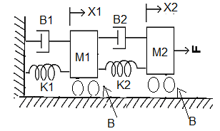
Obtain the mechanical equations and also draw the force voltage analogy and force current analogy of the given system. [9]
2. Determine the overall transfer function C(s)/R(s) for the system represented by the block diagram shown below.

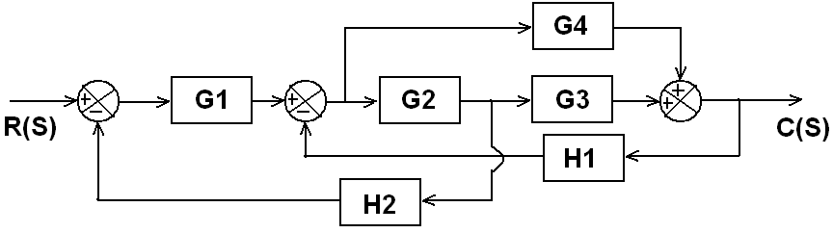

Also obtain the overall transfer function of the system using signal flow graph technique. [15]
3. a) The open loop transfer function of a unity feedback system is given as:
G(s)= K/(s³+ 2s +4)
Determine the range of K for which the system is unstable. [7]
b) Draw the overall block diagram for armature controlled DC motor. Also find the overall transfer function. [8]
4. a) The open loop transfer function of a unity feedback control system is given by
G(s)= K/{s(1+sT)}. Determine the value of K& T that will give the Maximum overshoot of 5% and the settling time (2%) of 2 second for the unit step input. [8]
b) The open loop transfer function of a unity feedback control system is given by
G(s)=K/{s (s+2) (s+10)} Find the static error constant and steady state error of the system when subjected to input
r(t) = 1 + t + (t²/2) [7]
5. Sketch the root locus plot for the open loop transfer function
G(s)H(s)= {K (s²+4)}/{s(s+2)} [15]
6. a) Explain frequency domain specifications of the control system with suitable example. [7]
b) The open loop transfer function of a certain unity feedback system is
G(s)= 1/{s(s+0.5)(s+0.1)}
Construct the Bode Plot. Also determine gain margin and phase margin and check stability. [8]
7. Write short notes on (Any two): [5*2=10]

a) Maximum overshoot
b) Stability of a system
b) Encoders

